Multi-Agent Architecture and A2A Specification
Section 3 — Apex Insurance Group Integrated Architecture Package

Project | Apex Insurance Group Integrated Architecture and Sign-off Package
Template Section | Section 3 — Multi-Agent Governance and A2A Security Design
Learner Name | Dennis Lam
Deliverable | AI-Graded File Upload (PDF)

Section summary. The Claims workflow uses an orchestrator-led pattern with conditional dynamic routing. A deterministic Claims Workflow Controller decides every transition from the typed outputs defined in Section 2, so a fraud anomaly reroutes the claim before the Settlement Specialist is engaged. Five components each have a single responsibility. The controller brokers the Fraud-to-Settlement A2A handoff and enforces four things on it: a 19-field allow-list drawn only from ClaimCaseOutput v1.0, PII redaction, a correlation ID that persists end to end, and Entra ID managed-identity authentication. Figure 1 shows the standard path and the escalation branches.

1. Governance Pattern Selection
Selected Pattern | Why Sequential Is Insufficient | How Selected Pattern Handles Conditional Routing
Orchestrator-led (hierarchical supervisor) pattern with conditional dynamic routing.  The Claims Workflow Controller (claims-workflow-controller), a Microsoft Agent Framework graph workflow with conditional edges, checkpointing and human-in-the-loop resume, is deployed inside proj-apex-claims-processing and owns all routing. Specialist agents never call each other. | - A strictly sequential pipeline (Intake → Policy → Fraud → Settlement) always passes Fraud’s output to Settlement. There is no point where a fraud signal can stop the chain, so a high-risk claim would still receive a settlement letter.  - It cannot pause one claim for a human decision and resume it later, so SIU review or an API outage would block or fail the whole run.  - Errors flow downstream: an INDETERMINATE fraud result would reach Settlement as missing fields, which is exactly the blank or incomplete letter the scenario prohibits.  - Routing logic would be buried inside agent prompts, where it cannot be audited or tested. | After the Fraud and Risk Specialist returns, the controller’s routing gate evaluates fraud_risk_score and risk_classification in deterministic code (rule set routing-rules v1.0), not by LLM judgment:  - HIGH (score ≥ 0.85): checkpoint, enqueue to sbq-siu-fraud-review; Settlement Specialist not engaged (ESC-002).  - INDETERMINATE: checkpoint, enqueue to sbq-external-verification-hold (ESC-005).  - ELEVATED (0.60 to 0.849), or claimed_amount_usd > $250,000: handoff with settlement_hold_required = true (ESC-006, ESC-001).  - LOW (< 0.60): standard handoff.  The earlier gates (ESC-003, ESC-004) and the post-Settlement validation gate (ESC-007) use the same mechanism. Every decision is emitted as span fraud.routing_decision with the rule ID that fired.

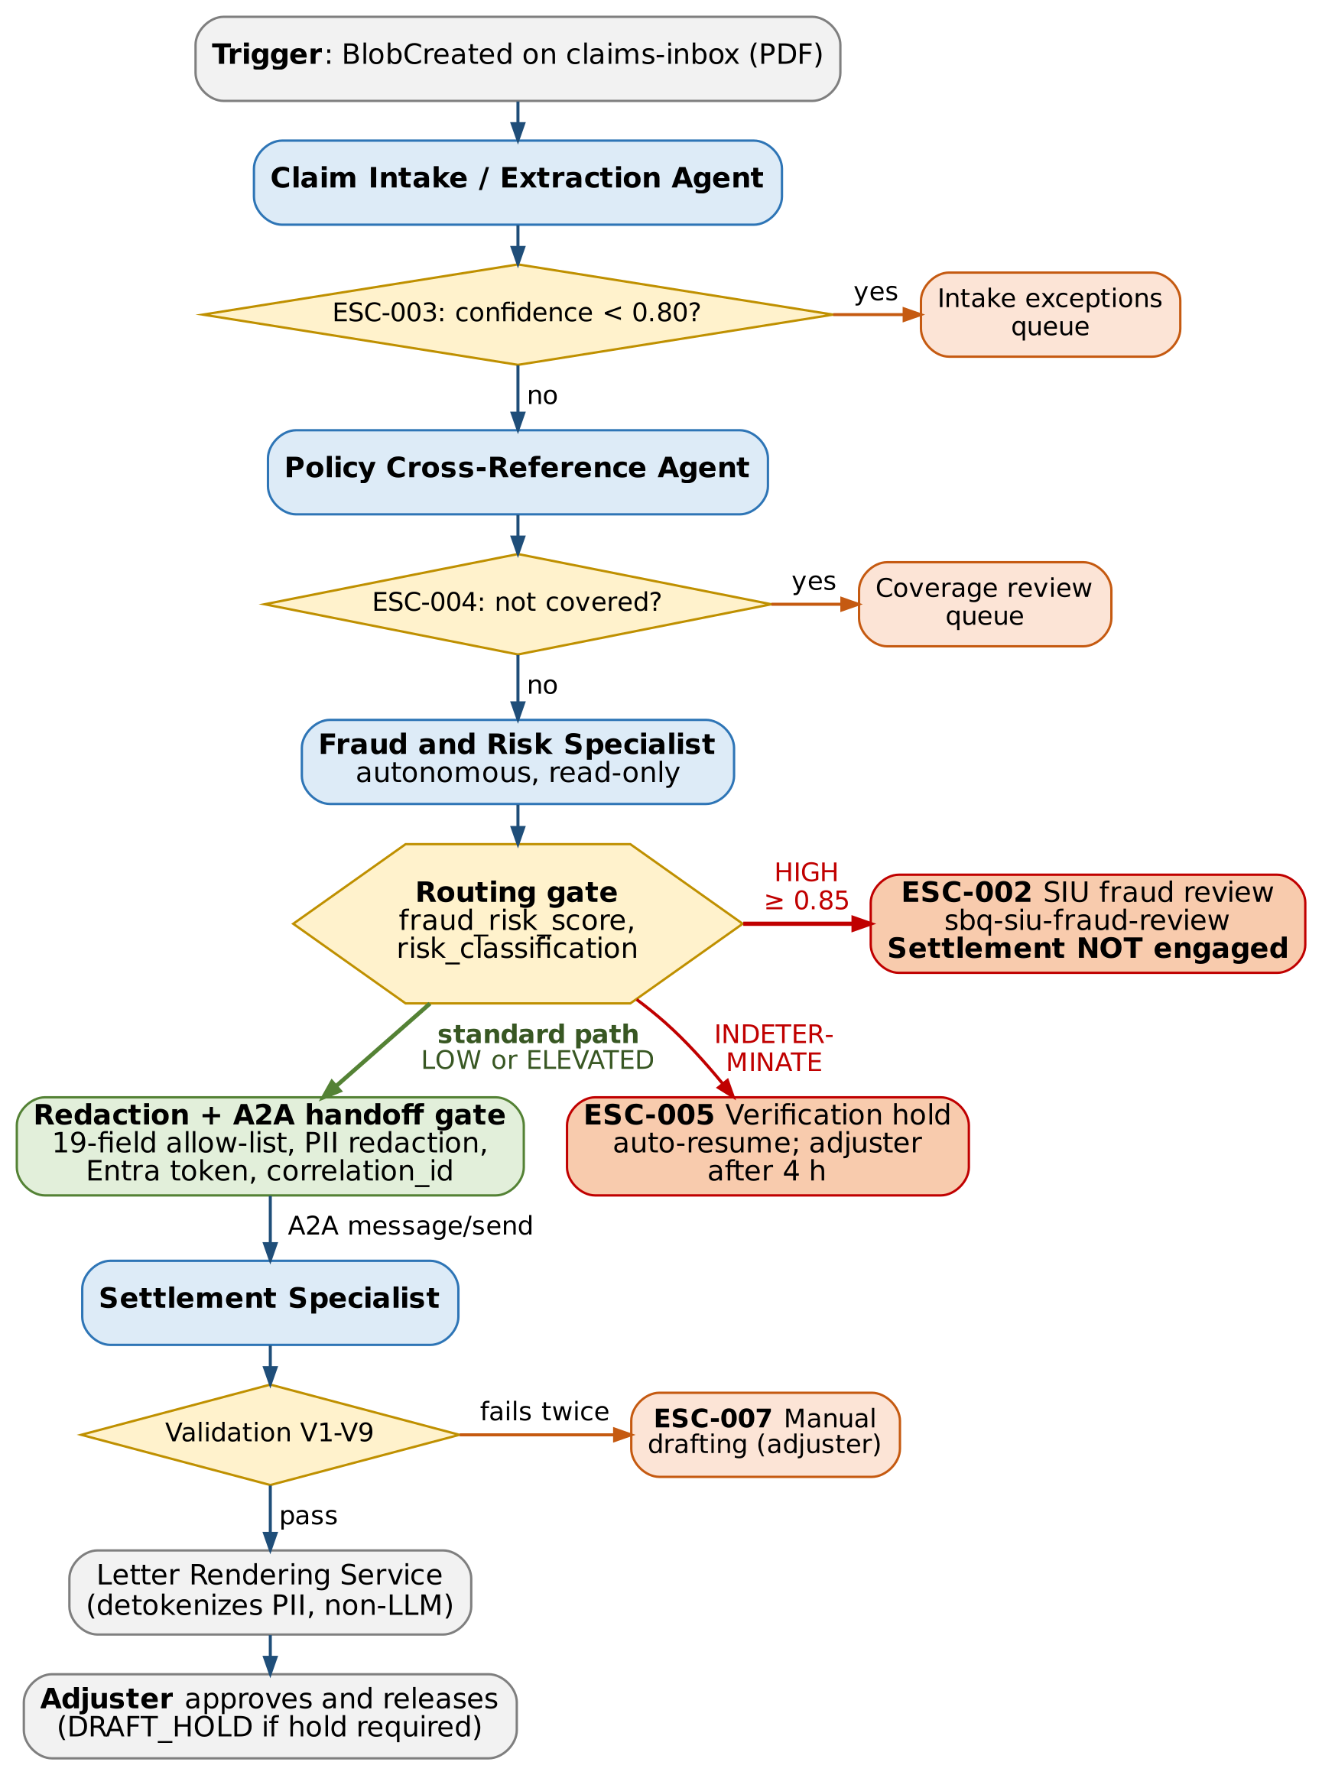
Figure 1. Standard handoff path (green) and escalation branches (red and orange), all executed by the Claims Workflow Controller

2. Agent Boundary Decomposition
Agent | Single Responsibility | Inputs Consumed | Outputs Produced | Can Trigger Escalation?
Claim Intake / Extraction Agent | Turn one claim PDF into structured, confidence-scored claim data. | Section 2 typed inputs: claim_document_ref, claim_id, policyholder_id, claim_submission_timestamp, submission_channel, supporting_document_refs, correlation_id | extracted_claim (including extraction_confidence_min) | Yes: ESC-003, raised by the controller from its output (confidence < 0.80 or a required field missing).
Policy Cross-Reference Agent | Determine coverage for the claim from the policy database. | policy_number, policyholder_id, date_of_loss, loss_type, claimed_amount_usd from extracted_claim | policy_cross_reference (policy_in_force_on_loss_date, coverage_status, coverage_limit_usd, deductible_usd, applicable_exclusions) | Yes: ESC-004 (not in force or NOT_COVERED).
Fraud and Risk Specialist | Classify fraud and risk with cited evidence. | insured_entity_name, property_address, date_of_loss, loss_type, claimed_amount_usd from extracted_claim; policy_cross_reference | fraud_assessment (fraud_risk_score, risk_classification, fraud_signals, public_records_check_status, evidence_refs, assessed_at) | Yes: ESC-002 (HIGH), ESC-005 (INDETERMINATE), ESC-006 (ELEVATED).
Settlement Specialist | Draft the settlement letter and recommended settlement amount. | Only the 19-field redacted handoff payload in item 3.3 | recommended_settlement_amount_usd and letter sections with merge tokens. The controller then sets letter_validation_status and the renderer sets settlement_letter_ref. | Yes: ESC-007 when its output fails validation after one regeneration.
Orchestrator / Workflow Controller | Route, gate and record the workflow. It does no claim reasoning. | Event Grid trigger; every agent output block; reviewer decision events from SIU and adjusters | routing (route, settlement_hold_required, escalation_ids), workflow_status, pii_tokens, redacted_claim_summary, checkpoints, queue messages, spans | Yes: it is the only component that raises escalations (ESC-001 to ESC-007).

3. A2A Handoff: Fraud and Risk Specialist → Settlement Specialist

3.1 Handoff Overview
Field | Learner Response
Handoff Name | Fraud Risk Assessment to Settlement Drafting
Source Agent | Fraud and Risk Specialist
Target Agent | Settlement Specialist
Standard Path Description | The handoff proceeds only when all of these are true:  - fraud_risk_score is non-null and < 0.85, and risk_classification is LOW or ELEVATED.  - public_records_check_status is COMPLETED, or CACHED (30 days old or less) when claimed_amount_usd ≤ $250,000.  - coverage_status is COVERED or PARTIAL.  - The fraud_assessment block validates against ClaimCaseOutput v1.0.  The controller then builds the 19-field payload (item 3.3), applies the PII rules (item 3.4), sets settlement_hold_required and sends the payload to the Settlement Specialist with A2A message/send.
Escalation Branch Description | The handoff must not proceed when fraud_risk_score ≥ 0.85 (HIGH). The controller checkpoints the workflow and routes the claim to the SIU queue, and the Settlement Specialist is never called (ESC-002).  It is also blocked when the result is INDETERMINATE (ESC-005), when the payload fails schema or redaction checks (fail closed), or while an SIU or adjuster decision is pending. A blocked handoff resumes only on an authenticated reviewer decision event; the decision and reviewer ID are recorded against the same correlation_id. Item 3.5 lists every branch.

3.2 Correlation and Authentication
Requirement | Learner Response
Correlation ID Format | {claim_id}.{workflow_run_id}: claim_id = CLM-YYYY-NNNNNNN, workflow_run_id = UUID v4 created by the controller at trigger time.  Example: CLM-2026-0048172.6f1c2a9e-4b7d-4e21-9a3f-2d8c5b7e0a14.  Each hop also gets a unique handoff_id (the A2A messageId, UUID v4) and a W3C traceparent header for distributed tracing.
Authentication Approach | Microsoft Entra ID bearer tokens from user-assigned managed identities only; no hard-coded credentials or API keys.  - The controller acquires a token for audience api://apex-claims-settlement-agent as uami-claims-workflow-controller and calls the Settlement Specialist’s A2A endpoint with Authorization: Bearer. The Settlement Specialist’s Agent Card declares an OAuth 2.0 / OpenID Connect (Entra ID) security scheme only.  - The endpoint validates the issuer (Apex tenant), audience and expiry, and checks that the caller holds app role Handoff.Submit. Only the controller’s identity holds that role, so the Fraud and Risk Specialist (uami-claims-fraud-risk) cannot call Settlement directly or bypass the routing gate.  - Traffic stays on private endpoints inside the Claims Project’s managed network, over TLS 1.2 or higher.
Audit Trace Requirement | - correlation_id travels as the A2A contextId and is repeated in the payload; the receiver rejects a mismatch.  - It is written as attribute apex.correlation_id on every span (invoke_agent …, fraud.routing_decision, pii.redaction, a2a.handoff, settlement_output.validation), as the Service Bus CorrelationId on every escalation message, and on the claim’s record in claim-cases.  - Span a2a.handoff records the sending and receiving agent IDs, the caller principal ID, handoff_id, timestamp, schema_version and the SHA-256 hash of the redacted payload, never the payload itself.  - Telemetry flows to appi-apex-claims-prod and is exported daily to immutable storage stapexclaimsaudit (time-based retention lock), so compliance can rebuild any claim’s full agent path from one ID.

3.3 Typed Handoff Schema
Field Name | Data Type | Required? | Source Field from Section 2 Output? | Description
claim_id | string | Yes | Yes: claim_id | Business key of the claim (CLM-YYYY-NNNNNNN); joins the handoff to the Restricted case record.
correlation_id | string | Yes | Yes: correlation_id | {claim_id}.{workflow_run_id}; also carried as the A2A contextId so every span and queue message for this run can be joined.
schema_version | string | Yes | Yes: schema_version | ClaimCaseOutput schema version ("1.0"); Settlement Specialist rejects unknown versions.
fraud_risk_score | number (float 0.00–1.00) | Yes | Yes: fraud_assessment.fraud_risk_score | Calibrated score from the deterministic score_fraud_signals tool. Must be non-null for a handoff to exist.
risk_classification | string (enum LOW | ELEVATED) | Yes | Yes: fraud_assessment.risk_classification | Only LOW or ELEVATED can cross this handoff; HIGH and INDETERMINATE are routed to the escalation branch.
fraud_signals | array<string> (FS-NNN codes) | Yes (may be empty) | Yes: fraud_assessment.fraud_signals | Signal codes only (e.g., FS-014 recent policy inception). No raw public-records content.
public_records_check_status | string (enum COMPLETED | CACHED) | Yes | Yes: fraud_assessment.public_records_check_status | Proves the external check ran live or from a ≤30-day cache; UNAVAILABLE never reaches Settlement.
redacted_claim_summary | string (≤1,500 chars) | Yes | Yes: redacted_claim_summary | Loss narrative after PII redaction (Section 3.4). Gives the letter its factual description of the loss.
coverage_status | string (enum COVERED | PARTIAL) | Yes | Yes: policy_cross_reference.coverage_status | From policy_cross_reference; NOT_COVERED claims are stopped earlier by ESC-004.
coverage_limit_usd | number | Yes | Yes: policy_cross_reference.coverage_limit_usd | Applicable limit used by calculate_settlement and checked by validation rule V5.
deductible_usd | number | Yes | Yes: policy_cross_reference.deductible_usd | Deductible applied in the settlement calculation and stated in the letter.
applicable_exclusions | array<string> | Yes (may be empty) | Yes: policy_cross_reference.applicable_exclusions | Exclusion clause IDs the letter must cite when coverage_status = PARTIAL.
claimed_amount_usd | number | Yes | Yes: extracted_claim.claimed_amount_usd | Amount claimed by the insured; input to calculate_settlement.
loss_type | string (enum) | Yes | Yes: extracted_claim.loss_type | Selects the letter template variant (e.g., WIND_HAIL).
date_of_loss | string (date) | Yes | Yes: extracted_claim.date_of_loss | Stated in the letter; already verified against the policy period by the Policy Cross-Reference Agent.
property_location_state | string (2-letter) | Yes | Yes: extracted_claim.property_location_state | Selects the state-specific disclosure clause; the only address element retained.
policyholder_token | string (PH-TKN-…) | Yes | Yes: pii_tokens.policyholder_token | Replaces insured name and address; resolved to real values only by the Letter Rendering Service.
policy_number_token | string (POL-TKN-…) | Yes | Yes: pii_tokens.policy_number_token | Replaces the policy number; resolved only at rendering.
settlement_hold_required | boolean | Yes | Yes: routing.settlement_hold_required | true when ESC-001 (large loss) or ESC-006 (elevated fraud risk) applies; the letter is then created as DRAFT_HOLD.
Excluded from the payload (data minimization): policyholder_id, policy_number, insured_entity_name, property_address, loss_description, evidence_refs, extraction_confidence_min. Transport envelope (A2A protocol fields, not business payload): messageId (= handoff_id), contextId (= correlation_id), traceparent, Authorization. The handoff schema FraudToSettlementHandoff v1.0 is generated from ClaimCaseOutput v1.0 with additionalProperties: false, so the Settlement Specialist rejects any field that is not listed above.

3.4 PII Redaction Rules
Data Element | Redaction Rule | Allowed Replacement / Token | Reason
Policyholder full name (insured_entity_name and any named contacts) | Remove from payload and tokenize. | policyholder_token (PH-TKN- + 16 random hex characters, mapping held in the Restricted pii-token-vault container); the letter uses merge field {{INSURED_NAME}} | Settlement does not need the identity to draft. Keeping names out of the LLM context stops them being misplaced or leaked in generated text. The real name is inserted only by the Letter Rendering Service.
Policyholder address (property_address and mailing address) | Remove street, unit, city and ZIP code; keep only the state. | property_location_state (for example, TX) plus merge field {{PROPERTY_ADDRESS}} | The state selects the state-specific disclosure clause; nothing finer is needed. The full address is re-inserted at rendering.
Policy number (policy_number) | Remove and tokenize. | policy_number_token (POL-TKN- + 16 hex); merge field {{POLICY_NUMBER}} | Policy numbers are linkable identifiers. The letter shows the real number only after rendering.
Free-text claim notes (loss_description, adjuster narrative) | Azure AI Language PII detection in redaction mode (lang-apex-claims-prod) for categories Person, PhoneNumber, Email, Address, USSocialSecurityNumber, USBankAccountNumber, ABARoutingNumber, CreditCardNumber, USDriversLicenseNumber; regex backstop for Apex policy and claim numbers; truncate to 1,500 characters. | redacted_claim_summary, with category placeholders such as [PERSON] and [PHONE] | Loss narratives often name witnesses, contractors and tenants, and include phone or bank details. If the redaction service fails, the handoff is blocked (fail closed).
Bank account, routing number, tax ID (EIN or SSN) | Never included. | None (dropped) | Payment is made after approval by the payments system, not by the letter-drafting agent.
Raw public-records evidence (third-party owner names, judgment and lien records) | Never included; only signal codes cross. | fraud_signals (FS-NNN codes) | Third-party PII is not needed for drafting. Evidence stays in fraud_assessment.evidence_refs in the Restricted case record for SIU use.
Insured and broker contact details (phone, email) | Never included. | None (dropped) | Delivery details come from the system of record at rendering time.
Enforcement: redaction runs in the controller’s handoff gate, not in an LLM. The steps are: field allow-list projection, then Language PII redaction on free text, then a regex backstop for policy-number and account-number patterns, then a hash of the redacted payload for span a2a.handoff. A failure at any step blocks the handoff and raises an alert. There is no unredacted fallback.

3.5 Escalation Branch
Escalation Condition | Threshold | Action Taken | Settlement Specialist Handoff Proceeds? | Destination
High-confidence fraud signal | fraud_risk_score ≥ 0.85 (risk_classification = HIGH), the same threshold as ESC-002 in Section 2 | Bypass the Settlement Specialist and route to fraud review: checkpoint to workflow-checkpoints, message to sbq-siu-fraud-review with CorrelationId, workflow_status = ESCALATED, route = SIU_REVIEW. | No | Special Investigations Unit investigator queue; owner SIU Manager; 2-business-day target
External check unavailable | public_records_check_status = UNAVAILABLE with no valid cache (INDETERMINATE); ESC-005 after 4 hours | Park as AWAITING_EXTERNAL_VERIFICATION with a checkpoint; resume automatically when the circuit closes. | No (until resolved) | sbq-external-verification-hold; assigned adjuster after 4 hours
Elevated risk | 0.60 ≤ fraud_risk_score < 0.85 (ESC-006) | Handoff with settlement_hold_required = true; letter created as DRAFT_HOLD. | Yes (held) | Assigned commercial property adjuster, who must approve before release
Large loss | claimed_amount_usd > $250,000 (ESC-001) | Handoff with hold; a live public-records result is required (CACHED not accepted). | Yes (held) | Large Loss Unit via sbq-large-loss-approval
Handoff integrity failure | Payload fails schema validation, redaction service error, or correlation_id mismatch | Block the handoff (fail closed) and alert Claims Platform on-call; re-run the gate after the fix. | No | Claims Platform Engineering on-call; claim moves to sbq-adjuster-review if not fixed within 1 hour
SIU clears a HIGH claim | SIU decision event = CLEAR, authenticated as an SIU investigator | Resume from the checkpoint; handoff proceeds with settlement_hold_required = true and the reviewer ID recorded. | Yes (held) | Assigned adjuster

Submission Checklist
☑ Selected governance pattern supports non-linear conditional routing.
☑ Agent boundaries name each specialized agent with one responsibility.
☑ A2A handoff includes correlation ID, typed schema, PII redaction, and authentication approach.
☑ PII redaction rules name specific data elements to redact.
☑ Fraud escalation branch prevents Settlement Specialist handoff when threshold is met.
☑ A2A schema fields align with Section 2 task agent output schema.

